Software Engineering – GitHub Exercise
Jonathan Tanuseputra – 2702234491

- Membuat Repository
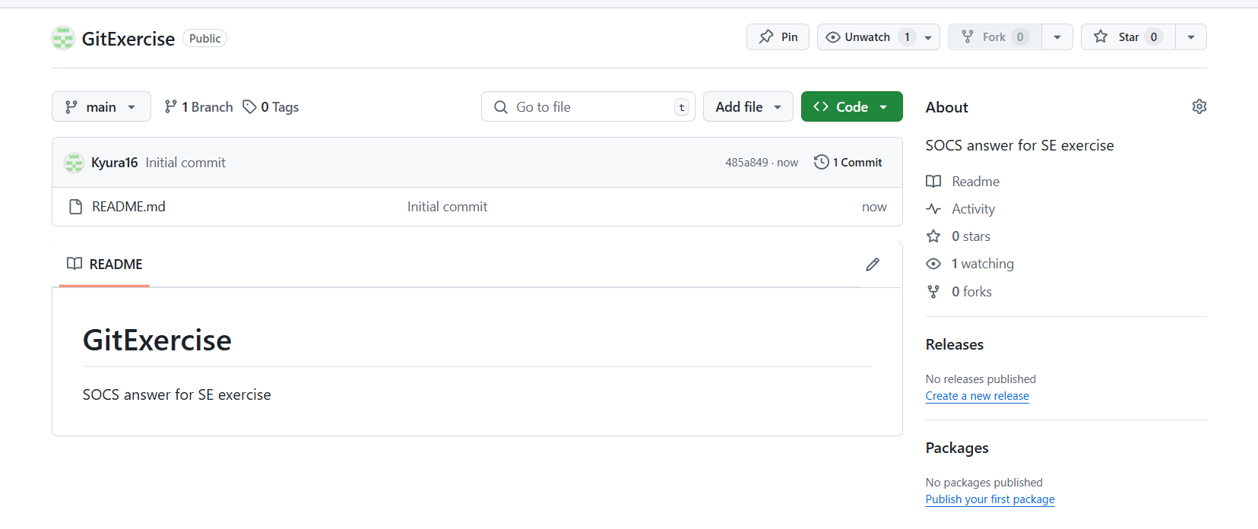
- Upload file ke repository
- Clone
